**Activity_main.xml:**

*<?*xml version="1.0" encoding="utf-8"*?>*<RelativeLayout xmlns:android="http://schemas.android.com/apk/res/android"  
 xmlns:tools="http://schemas.android.com/tools"  
 android:layout_width="match_parent"  
 android:layout_height="match_parent"  
 android:paddingBottom="@dimen/activity_vertical_margin"  
 android:paddingLeft="@dimen/activity_horizontal_margin"  
 android:paddingRight="@dimen/activity_horizontal_margin"  
 android:paddingTop="@dimen/activity_vertical_margin"  
 tools:context="com.DataFlair.dataflairtodolist.MainActivity">  
  
 <ListView  
 android:id="@+id/list_todo"  
 android:layout_width="wrap_content"  
 android:layout_height="wrap_content" />  
</RelativeLayout>

**Todo_task.xml:**

*<?*xml version="1.0" encoding="utf-8"*?>*<RelativeLayout xmlns:android="http://schemas.android.com/apk/res/android"  
 android:layout_width="match_parent"  
 android:layout_height="match_parent"  
 android:layout_gravity="center_vertical">  
  
 <TextView  
 android:id="@+id/title_task"  
 android:layout_width="wrap_content"  
 android:layout_height="wrap_content"  
 android:layout_alignParentLeft="true"  
 android:layout_alignParentStart="true"  
  
 android:textSize="20sp" />  
  
 <Button  
 android:id="@+id/task_delete"  
 android:layout_width="wrap_content"  
 android:layout_height="wrap_content"  
 android:layout_alignParentEnd="true"  
 android:onClick="deleteTask"  
 android:layout_alignParentRight="true"  
 android:text="Task Completed" />  
  
</RelativeLayout>

**MainActivity.java**

package com.DataFlair.dataflairtodolist;  
  
import androidx.appcompat.app.AlertDialog;  
import androidx.appcompat.app.AppCompatActivity;  
  
import android.os.Bundle;  
  
import android.content.ContentValues;  
import android.content.DialogInterface;  
import android.database.Cursor;  
import android.database.sqlite.SQLiteDatabase;  
import android.view.Menu;  
import android.view.MenuItem;  
import android.view.View;  
import android.widget.ArrayAdapter;  
import android.widget.EditText;  
import android.widget.ListView;  
import android.widget.TextView;  
  
import com.DataFlair.dataflairtodolist.task_database.TaskContract;  
import com.DataFlair.dataflairtodolist.task_database.TaskDatabaseHelper;  
  
import java.util.ArrayList;  
  
public class MainActivity extends AppCompatActivity {  
 private static final String *TAG* = "MainActivity";  
 private TaskDatabaseHelper taskHelper;  
 private ListView TaskList;  
 private ArrayAdapter<String> arrAdapter;  
  
 @Override  
 protected void onCreate(Bundle savedInstanceState) {  
 super.onCreate(savedInstanceState);  
 setContentView(R.layout.*activity_main*);  
  
 taskHelper = new TaskDatabaseHelper(this);  
 TaskList = (ListView) findViewById(R.id.*list_todo*);  
  
 updateUI();  
 }  
  
 @Override  
 public boolean onCreateOptionsMenu(Menu menu) {  
 getMenuInflater().inflate(R.menu.*main_menu*, menu);  
 return super.onCreateOptionsMenu(menu);  
 }  
  
 @Override  
 public boolean onOptionsItemSelected(MenuItem item) {  
 switch (item.getItemId()) {  
 case R.id.*action_add_task*:  
 final EditText taskEdit = new EditText(this);  
 AlertDialog dialog = new AlertDialog.Builder(this)  
 .setTitle("Add a new task").setMessage("What do you want to do next?").setView(taskEdit)  
 .setPositiveButton("Add", new DialogInterface.OnClickListener() {  
 @Override  
 public void onClick(DialogInterface dialog, int which) {  
 String task = String.*valueOf*(taskEdit.getText());  
 SQLiteDatabase db = taskHelper.getWritableDatabase();  
 ContentValues values = new ContentValues();  
 values.put(TaskContract.TaskEntry.*COL_TASK_TITLE*, task);  
 db.insertWithOnConflict(TaskContract.TaskEntry.*TABLE*, null, values, SQLiteDatabase.*CONFLICT_REPLACE*);  
 db.close();  
 updateUI();  
 }  
 })  
 .setNegativeButton("Cancel", null).create();  
 dialog.show();  
 return true;  
  
 default:  
 return super.onOptionsItemSelected(item);  
 }  
 }  
  
 public void deleteTask(View view) {  
 View parent = (View) view.getParent();  
 TextView taskTextView = (TextView) parent.findViewById(R.id.*title_task*);  
 String task = String.*valueOf*(taskTextView.getText());  
 SQLiteDatabase db = taskHelper.getWritableDatabase();  
 db.delete(TaskContract.TaskEntry.*TABLE*, TaskContract.TaskEntry.*COL_TASK_TITLE* + " = ?", new String[]{task});  
 db.close();  
 updateUI();  
 }  
  
 private void updateUI() {  
 ArrayList<String> taskList = new ArrayList<>();  
 SQLiteDatabase db = taskHelper.getReadableDatabase();  
 Cursor cursor = db.query(TaskContract.TaskEntry.*TABLE*,  
 new String[]{TaskContract.TaskEntry.*_ID*, TaskContract.TaskEntry.*COL_TASK_TITLE*},  
 null, null, null, null, null);  
 while (cursor.moveToNext()) {  
 int idx = cursor.getColumnIndex(TaskContract.TaskEntry.*COL_TASK_TITLE*);  
 taskList.add(cursor.getString(idx));  
 }  
  
 if (arrAdapter == null) {  
 arrAdapter = new ArrayAdapter<>(this, R.layout.*todo_task*, R.id.*title_task*, taskList);  
 TaskList.setAdapter(arrAdapter);  
 } else {  
 arrAdapter.clear();  
 arrAdapter.addAll(taskList);  
 arrAdapter.notifyDataSetChanged();  
 }  
  
 cursor.close();  
 db.close();  
 }  
}

**Output:**

**To Do List**

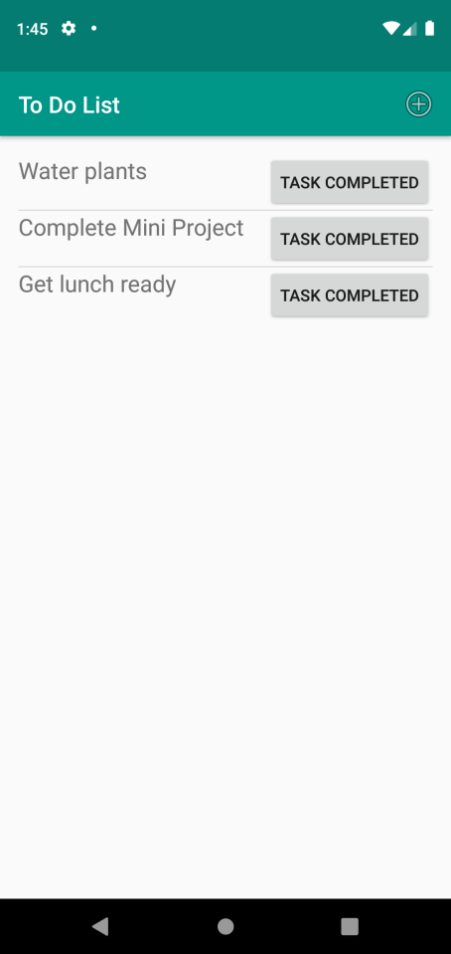

**Add New Task**

